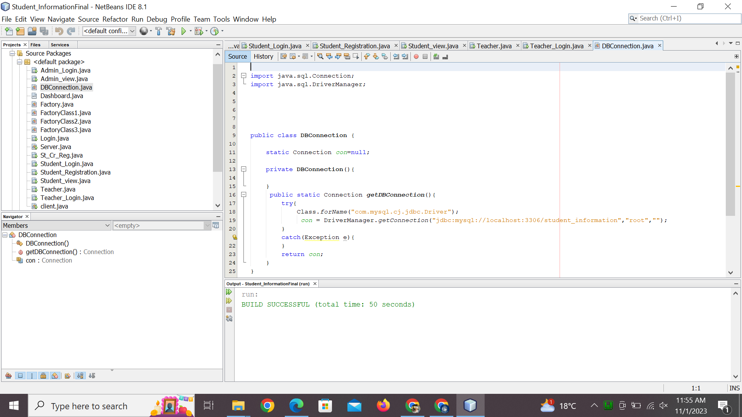

import java.sql.Connection;

import java.sql.DriverManager;

public class DBConnection {

static Connection con=null;

private DBConnection(){

}

public static Connection getDBConnection(){

try{

Class.forName("com.mysql.cj.jdbc.Driver");

con = DriverManager.getConnection("jdbc:mysql://localhost:3306/student_information","root","");

}

catch(Exception e){

}

return con;

}

}